Section 3

A radionuclide has a radiological half-life of 30 days and a biological half-life of 20 days. What is the effective half-life?

A. 10 days



**B. 12 days**



C. 25 days



D. 50 days

You measure an exposure rate of 100 mR/hr at two feet from the source. How far away should you be from the source to measure 10 mR/hr?

A. 4.2 feet



B. 1 foot



C. 6.3 feet



D. 20 feet

You will need a whole body badge to work with all of the following except:

A. Neutron sources



B. X-ray equipment



C. 0.3 mCi of a 100 keV gamma emitter



D. 0.3 mCi of a 400 keV beta emitter

The maximum permissible ALI for internal emitters allows you to receive a CEDE of 5 rem per year to the whole body. However, you also work with external sources of radiation and receive 2 rem per year from those sources. Which of the following is true?

A. Federal and state regulations state that you cannot receive more than 5 rem from all sources combined. You will have to limit your exposure to one or both sources to stay within 5 rem total.

B. The ALI is not covered by the federal and state regulations, so it does not count toward the federal/state limits.

C. The maximum ALI of 5 rem and the federal/state limit of 5 rem pertain to different sources of radiation, so you can get up to 5 rem from each source.

D. All of the above

You have a radionuclide that emits both high energy beta particles and gamma rays.  What should you use to shield it?

A. A container of lead



B. A container of Plexiglas



C. A container of Plexiglas inside a container of lead



D. A container of lead inside a container of Plexiglas

Am I required to participate in the bioassay program if I work with tritium or iodine?

A. Yes



B. No



C. It depends



D. None of the above

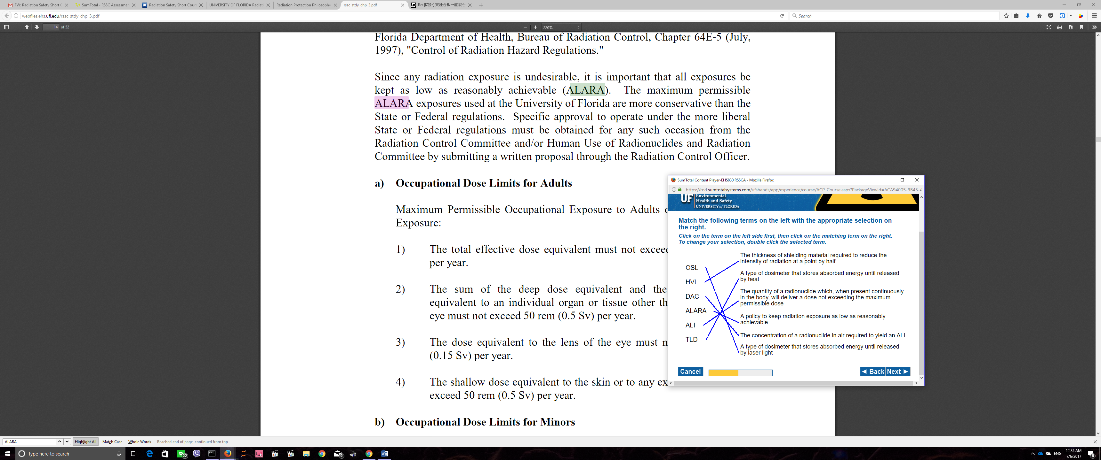

A box has a “Radioactive II” sticker on it. What do you know about it?

A. The dose on the surface of the package does not exceed 50 mR/hr.



B. The dose at 3 feet does not exceed 1.0 mR/hr.



C. No special handling precautions are necessary.



D. Both A and B



E. All of the above

Which of the following radiation workers exceeded his or her dose limit?

A. Dave received an annual whole-body dose of 300 mrem.



B. Julie received an annual dose of 10 rem to her hands.



C. Carlos received an annual dose of 20 rem to the lens of his eye.



D. Sarah received a monthly dose of 25 mrem to her fetal badge.



E. None of the above

You are working with a high energy beta emitter.   
You should NOT shield it with:

A. Plastic



B. Aluminum



C. Brass



D. Lead

You are working in a radiation field with a dose rate of 500 mrem/hr. How long can you stay in that field before your dose reaches 300 mrem?

A. 4 minutes



B. 18 minutes



C. 36 minutes



D. 42 minutes

All of the following are advantages of OSL dosimeters except:

A. They are sensitive to a wide range of photon and beta particle energies.



B. They can be read multiple times.



C. They can be read on-site.



D. They are not very sensitive to heat, light, or humidity.

A sign posted on a door says “Radiation Area.” This means

A. there is radioactive material present.



B. the level of radiation exceeds 5 mR/hr or 100 mR in 40 hours.



C. the level of radiation exceeds 100 mR/hr.



D. no one should enter

The half value layer of lead for Cs-137 is 0.536 cm. What thickness of lead do you need to reduce the exposure rate from 64 mR/hr to 2 mR/hr?

A. 0.536 cm



B. 2.68 cm



C. 5 cm



D. 17 cm

$$2^{n}=\frac{64}{2}$$

N = 5

0.536*5 = 2.68

A lab worker accidently inhales a radioactive aerosol. It is possible for the radionuclide to exit the body in which way(s)?

A. Exhalation



B. Sweat



C. Urine



D. Feces



E. All of the above